Finance Guidance
2026 – 2027
May 2026

Biodiversity Challenge Funds:

Darwin Initiative

Illegal Wildlife Trade Challenge Fund

Darwin Plus (see separate financial guidance for Darwin Plus Local)


The Terms and Conditions are the primary source of information for all financial issues relating to the grants. This document is for guidance only and should be read alongside the:
- Guidance for Applicants, and
- Terms and Conditions (T&Cs)
This document is for applicants and grantees of the Biodiversity Challenge Funds (Darwin Initiative, the Illegal Wildlife Trade Challenge Fund, and Darwin Plus) and explains:
- What budget information you need to provide in your application.
- How payments will be made and how budgets need to be managed.
- How to report finance.
Please ensure that the described processes and standards can be delivered by your organisation before you apply.
Non-compliance with the guidance and T&Cs may result in an ineligible application or place your project at risk.
Please read all the available guidance including the separate Finance Guidance before requesting additional assistance, as these provide answers to most queries.
Further resources and templates to support your application are available on the relevant fund websites (see below), including:
Application Forms (for drafting purposes)  Application Templates  Flexi-Grant User Guide  Claim Forms |  | Change Request Forms  Terms and Conditions  Reporting Forms  Project Pages
For Finance specific questions, please contact BCF-Finance@niras.com.
If you can’t find the answer, please contact the Administration Team for the specific fund:
Calls (Teams/Zoom/Phone) can be arranged by email.
Darwin Initiative | IWT Challenge Fund |  | Darwin Plus
darwininitiative.org.uk | iwt.challengefund.org.uk |  | darwinplus.org.uk
BCF-Darwin@niras.com | BCF-IWTCF@niras.com |  | BCF-DPLUS@niras.com
c/o NIRAS, Pentlands Science Park, Bush Loan, Penicuik, UK, EH26 0PL


© Crown copyright 2026
You may re-use this information (excluding logos) free of charge in any format or medium, under the terms of the Open Government Licence v.2. To view this licence visit www.nationalarchives.gov.uk/doc/open-government-licence/version/2/ or email PSI@nationalarchives.gsi.gov.uk
Any enquiries regarding this publication should be sent to us at biodiversitychallengefunds@defra.gov.uk

Glossary
Actual Claim | Claim at the end of the Financial Year or at project end confirming actual spend for the period since the last Actual Claim.
BCFs | Biodiversity Challenge Funds - Collective name for Defra’s Darwin Initiative, Illegal Wildlife Trade Challenge Fund and Darwin Plus.
Capability & Capacity | Capability refers to the types of ability (skills and knowledge) required for a task; Capacity refers to the amount of ability at a point in time to deliver a task.
Defra | Darwin Initiative is a programme of the Department for Environment, Food and Rural Affairs (Defra), UK Government.
Evidence | Information that supports a claim. Can be used to make the case for a particular approach towards achieving change. Can also demonstrate a project’s activities have been carried out, and that outputs, outcomes and impact have been observed. It ranges in format and in quality, includes documented and undocumented experiences, data, studies, policies and practices from a range of perspectives. Evidence is particularly valued when it is quality assured, accessible and applicable.
Financial Year | The UK Government year, which runs from 1st April to 31st March. Budgets and financial management for all projects must follow this timing.
Fund Administrator | The organisation contracted by Defra who is the first point of contact for projects and applicants. The current Fund Administrator is NIRAS.
Lead Applicant | The individual who leads on the submission of the application and supporting materials, and will be the project contact point during the application process.
Lead Organisation | The organisation who will administer the grant and coordinate the delivery, accepting the Terms and Conditions of the Grant on behalf of the project.
Local/national organisations | Organisations of an eligible country, with either a national or local remit, always formally registered within that country, and typically led by a national of the country.
Logframe | Logframes are a monitoring tool to measure progress against a Results Chain, comparing planned and actual results along a causal pathway, and including indicators, baselines, targets, as well as risks and assumptions.
Matched Funding | Additional finance that is secured to help meet the total cost of the project, including public and private sources, as well as quantified in-kind contributions.
ODA | Official development assistance – commonly known as overseas aid – is when support, expertise or finance is supplied by one government to help the people of another country via activities that promote economic development and welfare as a main objective.
Partner(s) | Have a formal governance role in the project, and a formal relationship with the project that may involve staff costs and/or budget management responsibilities.
Project Leader | The individual with the necessary authority, capability and capacity, and a full understanding of their role and associated obligations, who takes responsibility for delivering value for money, managing risk and financial controls whilst fulfilling the terms and conditions of the grant.
Retention | The sum withheld at the end of your project until you meet all the reporting and financial requirements.
Scale | The ability to deliver greater impact of a proven approach, either through expanding the scope of activities within a given geography or focal issue, taking the approach into a new geography or focal issue, or through uptake by stakeholders that promotes systemic change.
Stakeholder | Are consulted, engaged and/or participate in project activities as they have an interest or concern in the project and its impact. They can also be partners, but if not, they would not have a budget management, or a formal governance role, within the project.
Theory of Change | Explains the process of change by outlining causal linkages taking activities through to a desired outcome, being explicit about the assumptions underlying the expected causal pathways, and including an analysis of barriers and enablers as well as indicators of success. Often set out in a diagram and narrative form.
Value for Money | Good value for money is the optimal use of resources to achieve the intended outcomes. See Annex B.

Contents
Glossary ……………………………………………………………………………………………………………………….2
1 Introduction 5
2 Pre-award: Preparing Your Application 5
2.1 Staff Costs 7
2.2 Consultancy Costs 8
2.3 Overheads 8
2.4 Travel and Subsistence 9
2.5 Operating Costs 9
2.6 Capital Costs (Assets) 9
2.7 Other Costs 10
3 Pre-award: Budget requirements at application 12
3.1 Single Stage Application Processes 12
3.2 Two Stage Application Processes 12
4 Pre-award: Financial Capability and Capacity Assurance 14
4.1 Financial obligations of the grant holder 14
4.2 Lead Organisation 14
4.3 Submitting your organisation’s accounts 15
5 Post-award: Claims and processes 16
5.1 Standard Payment Procedures 16
5.2 How the claims process works 17
5.3 Payment Schedules 18
5.4 Conditions for Payment 21
6 Post-award: Managing your budget 22
6.1 Good Practice 22
6.2 Spend relating to Financial Year 22
6.3 Project Change Requests 23
6.4 Foreign exchange 23
6.5 Forecasting 23
6.6 Financial Assurance (Audits) 24
6.7 Spot Audits on expenditure and procedures 25
Annex A. Items ineligible for funding 26
Annex B. High Level Budget Characteristics 27
Value for Money 27
Matched Funding 29
Budget spread 29
Balance of funding between partners 29
Monitoring, Evaluation and Learning 30
Contingency 30
‘Sitting’ payments 30

Introduction
This document is our comprehensive financial guidance for organisations applying to, or delivering a grant under, the Biodiversity Challenge Funds (BCFs) for the below funds and schemes. At Defra, we understand the importance of fiscal responsibility and transparency in utilising grant funds efficiently and effectively. This guide aims to assist you in preparing robust budgets, navigating the application process, and managing finances if awarded.
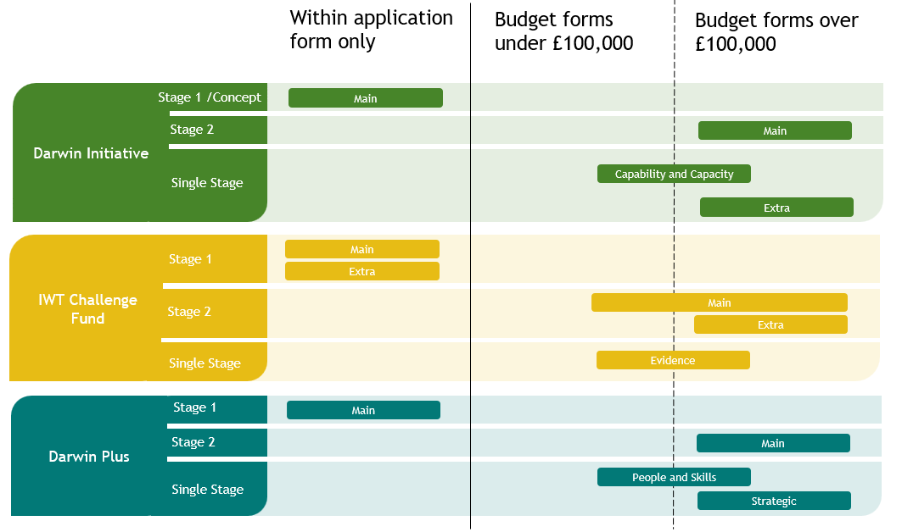
If you have any questions or need further assistance after reading this guidance, please don't hesitate to contact the Fund Administrator who is there to support you every step of the way.

Pre-award: Preparing Your Application
The information provided in the pre-award stages needs to provide enough detail to allow reviewers to make evidence-based decisions during assessment. Costs are rigorously examined during the assessment process and funding decisions are based on whether proposed costs are realistic and justifiable to deliver the work plan, as well as demonstrating value for money.
The correct Budget Form template must be used, or your application will be rejected.
Exception: For two-stage application processes, the Stage 1 submission does not require a separate Budget Form. However, applicants are strongly encouraged to familiarise themselves with the budget guidance to ensure they can later submit a complete Stage 2 application. The Stage 1 budget should be realistic but may be refined if you are invited to Stage 2.
The Budget Form must match the details provided in the application form; any discrepancies will undermine confidence in the quality of the application and your capacity to manage a project.
Defra may request additional information or evidence to support your application.
Key requirements:
- A fully costed budget must be presented in GBP (Sterling).
- All budgets must use the 1st April to 31st March financial year.
- The fully costed budget must cover the lifespan of the project, split by financial years, and show all required project costs including matched funding in the financial year in which you expect the costs to be incurred.
- If preparing a budget in another currency, you must state the exchange rate used, its source, and maintain records showing values in GBP (and local currency if appropriate).
- Project start and end dates must be eligible and clearly identified. All financial commitments must be completed by the end date, within the maximum duration of the grant, and within the financial year in which the cost is budgeted. Costs cannot be moved between financial years without prior approval).
- Budgets must be realistic, and justifiable in what they cover and when funds are needed, so that they accurately forecast spend by financial year and, ideally, quarterly within each year.
- Costs should reflect expected actual expenditure and be presented in whole pounds (GBP) to avoid rounding issues.
- We expect a significant portion of funding to be directly benefiting in-country project partners, rather than meeting the costs for international partners and their team.
- Audit costs must be included, either as part of the funding request or as matched funding.
Planning for Risks
When developing your budget, consider potential risks that may disrupt planned activities, for example:
- Recruitment: your project plan should allow realistic time for recruitment, taking into account contextual challenges (such as the job being in a remote location, or for a very specialist role);
- Timing of events which may be subject to minor disruption If an activity (e.g., a workshop) is scheduled for late in the financial year, consider whether slippage could occur and whether moving it to April would reduce the risk of needing to request a budget reprofile.
- Changes in government: if forthcoming elections which may affect your project are known, build in time to manage this event and plan your budget accordingly.
Budget changes between financial years will only be considered in justified and exceptional circumstances, following formal agreement with Defra (Section 6.3).
Full accounting records, including original receipts and invoices, must be kept for seven years after project completion and be made available if requested.
Final awards may be subject to negotiation with Defra and financial guidance and processes may be updated over time.

Staff Costs
The Staff Costs budget line should capture all costs and payments for services relating to named individuals working on the project. This includes:
- salary payments made to team members for their time spent working on the project. Staff Costs apply to individuals employed by the Lead Organisation and by partner organisations;
- national insurance, or other social security costs and contractual pension contributions, and other reasonable contractual employment benefits. Do not use the term ‘fringe benefits’ – instead clearly describe the specific benefit.
The Staff Costs budget line should NOT include:
- external consultancy payments (see Section 2.2);
- any non-contractual bonus or other non-contractual payment or benefit;
- activities that would normally be part of a government or agency’s core functions;
- the costs of individuals providing short, localised input such as cooking for a field team or administering a workshop: these should be covered under Travel and Subsistence (section 2.4) or Operating Costs (section 2.5).
Required Information
The information provided must include the information requested in the spreadsheet, including:
- the individual’s name and role in the project (all individuals/roles listed in the application as Key Staff should appear in the budget);
- their main location;
- the percentage of their time given to the project during that period (as opposed to other projects/activities);
- the actual cost to the BCFs,;
any costs covered by other sources. Evidence of the employment costs (i.e. employment contract and payslips) and proof of actual time worked on the project (i.e. from timesheets) may be requested.
Additional Guidance
Staff Costs should include any expected salary increments (including projected annual inflationary increments) during the project, up to a maximum of 5% per annum.
PhD students can be included as staff if it can be demonstrated that they have appropriate expertise and experience; any stipend costs can be included under Staff Costs and the student is free to use any income as they see fit. Tuition fees for PhD students cannot normally be claimed.
Staff Costs included in the budget should match the details you are required to provide on Staff Costs in the Actual and Final claim forms. These are available for review in the “Resources” section of the relevant fund’s website.
Defra may ask for Staff Costs to be reduced or clarified if they are considered too high.
Foreign governments and their agencies cannot lead on projects, though they may be partners. UK government agencies, including UK Overseas Territories governments, are eligible to apply for funding and are acceptable Lead Organisations.
BCFs funding cannot be used as a substitute for activities that would normally be part of the government or agency’s core functions (e.g. full-time staff salaries or routine management activities).

Consultancy Costs
Consultancy seeks to fill a knowledge gap. It is defined as the provision of objective expert advice relating to strategy, structure, management or operations of an organisation. Such advice will be provided outside the ‘business-as-usual’ environment when in-house skills are not available and will be time-limited. Consultancy often includes the identification of options with recommendations, or assistance with the implementation of solutions, but typically not the delivery of business-as-usual activity.
For projects, this can include the contracting of someone to provide expertise required for the success of the project, and which cannot be delivered by project staff or captured under Staff Costs. Staff Costs of Partners should not be captured as Consultancy Costs.
Please clearly identify who will provide the expertise and what it will achieve. E.g. ‘ABC Company – training in enforcement methods’ or ‘J Smith – business skills training’.

Overheads
The BCFs will fund actual direct project costs plus reasonable and justifiable overheads related to the project; but will not subsidise other activities of organisations.
To be considered reasonable and justifiable, the overheads claimed must be less than or equal to the organisation’s actual overheads for the project and appropriately apportioned between all its activities or projects.
The amount claimed under the overhead budget line should be appropriate, reasonable, and justifiable, and able to be supported by evidence, audited financial statements and/or internal policies. Defra will decide whether the level of overheads charged is reasonable by considering:
- the proportion of total overheads claimed is not greater than 20% of the project’s total budget (i.e. BCFs plus additional funds), AND
- the proportion of overheads claimed in any year from the BCFs should not be greater than 40% of the ‘Staff Costs’ for that year.
All other budget lines must contain only direct project costs, with no overheads. For example, the ‘Staff Costs’ budget line covers employment costs (salary, employer’s National Insurance Contributions and pension contributions) for the people working on the project, limited to the time they spend working on it. The costs associated with general management, administration, or finance functions should be covered through overheads rather than staff costs, unless there is a specific role identified that is necessary to the project.
If the Lead Organisation or partners use Full Economic Costing (FEC) as standard practice, Defra will accept this method to account for overheads. However, the FEC % applied cannot be more than 40% of the budgeted salary costs. Effectively, if justified by your formal FEC policy, up to a maximum of 140% of salary costs can be funded, 100% under the Staff Cost budget line and 40% under the overhead budget line. A copy of the formal FEC policy must be available if requested, with evidence that it is standard practice to apply the policy across the organisation, not just to selected projects.

Travel and Subsistence
Travel and Subsistence (T&S) costs should be clearly justified and offer the best value available.
Defra may ask you to justify or reduce your T&S budget if they believe it is excessive.
Costs should follow your organisation’s policy and take into consideration the list of items we cannot fund (see Annex A); Defra reserves the right to request a copy of this policy.
To minimise carbon emissions, you should limit air travel wherever possible.
International travel should be presented separately from local travel.
Local travel is within the country or region where the project operates. This could include field travel costs and you may want to include those as an additional line if significant.

Operating Costs
Operating Costs are those specific to the project. For example, if you need to set up a local office for this project alone, you will show your costs here. If you have a local office that supports more than this project, we expect to see any related project costs under Overheads.
This is also where you can budget for other project specific costs such as workshops or the hire of tents for fieldwork.
To ensure transparency and to provide adequate information for reviewers, applicants should provide a reasonable breakdown of Operating Costs rather than a single aggregated figure; any substantial cost items should be clearly itemised, and additional rows can be added to the template if needed (contact Niras if required).
Within the space available, please ensure that any significant costs are clearly identified.

Capital Costs (Assets)
Capital costs are long life/high value items (assets) which may include vehicles, large pieces of equipment, and other assets, with a useful life span of more than one year and a cumulative cost of £1,500 or more, and either
(1) the purchase price or development cost of an individual asset is in excess of £1,500 or equivalent in local currency; or
(2) is a group of lower value items that are mobile and considered attractive (e.g. mobile phones, cameras, laptops, tablets, satellite phones, vehicles, food, pharmaceutical products, relief packs, trackers etc.) with a combined purchase price or development cost in excess of £1,500 or equivalent in local currency.
Purchases of assets should be in line with the agreed budget, and will typically occur early in the project; please consider carefully the timing to provide best value for money.
Any assets should represent the best value for money for delivering the project, as opposed to other approaches such as hiring or leasing.
Capital costs should be no more than 10% of the total grant, except in specific cases where higher capital expenditure is essential and is clearly justified/explained in the application.
For items over £1,500, 3 quotes (in so far as there are enough suppliers) must be obtained and retained to demonstrate your choice represents value for money; Defra may request to see this evidence.
An up-to-date inventory of all assets must be maintained with at least annual physical checks conducted to detail the condition. The project should have an asset register (template available) and it should be up-dated on a regular basis. Defra may request to see this.
If any asset (obtained with BCFs grant finance) is sold, a share of the proceeds in the same ratio as the grant contribution to the cost should be refunded to Defra or offset against any further approved expenditure.
Projects are expected to act as responsible stewards of all assets purchased with BCF funds. Where an asset is no longer required, any disposal must follow environmentally responsible methods and comply with local regulations. Assets should continue to support the original aims of the project or provide similar community or conservation benefit; they must not be sold for private gain. The final report must include a brief summary of the key assets acquired, their intended use after project completion, and any transfers to partner organisations. Defra may request a short follow-up update on the use or disposal of key assets to understand the ongoing impact of our funding. In exceptional cases where there is evidence of misuse, Defra reserves the right to review the use of assets and request corrective action.

Other Costs
Any project costs that do not fall under the headings above will fall under Other Costs, including financial assurance (audits), translations, publications relevant to the project objective, Open Access costs and bank charges related to transferring funds to partners.
To ensure transparency and to provide adequate information for reviewers, applicants should provide a reasonable breakdown of Other Costs rather than a single aggregated figure; any substantial cost items should be clearly itemised, and additional rows can be added to the template if needed (contact Niras if required).

Financial Assurance
The cost to organise an audit/independent examination of funds must be allocated in the project budget whether you are claiming funds from the BCFs or not. For the BCFs these costs are ring-fenced, and any underspend may not be reallocated elsewhere. You must organise this and deliver the assurance within the timing required for your project.
For grants where the total value is between £50,000 and £99,999, up to £3,000 can be claimed; for grants above this threshold, £4,000 can be claimed each financial year as required. For grants of over £1,000,000, projects are required to provide an annual grant statement; all other projects over £50,000 are only required to provide end of project audits (see current Terms and Conditions for further details). If audit budget limits are difficult to meet in the country where the project operates, applicants should contact the Fund Administrator to discuss suitable alternatives.
Audit requirement and costs available
Total Grant from BCF | Audit requirement | Maximum from BCF
Less than £50,000 | None | £0
£50,000 to £99,999 | End of project only | £3,000
£100,000 to £1,000,000 | End of project only | £4,000
More than £1 million | Annual | £5,000 pa

Open Access costs
Please consider the project outputs and how this information can be shared widely with others.
Appropriate costs can be included in the budget to ensure open access publishing.
These costs often fall in the last financial year of the project or beyond the close of the project, so it is worth considering matched funding for these costs. You can prepay costs for publication or audit costs, but you cannot use project funds for activities after the end date of the project.

Depreciation
Any allowable depreciation (calculated using acceptable accounting standards) in relation to capital items purchased specifically and exclusively for the project, and not covered by Overhead Costs, should be claimed under the Capital Costs.
Assets purchased specifically and exclusively for the project with grant finance, should be claimed as a Capital Cost in the year in which the asset is bought.
Depreciation for the use of assets already owned by the grantee is not an eligible expenditure.

Bank charges
You can include bank charges where they are specifically relevant to your project, such as the transfer of funds to partners.

Pre-award: Budget requirements at application
The budget template to use for your application depends on the amount requested (see Figure 1 for more information in addition to the text below).

Single Stage Application Processes
The budget for single stage application processes should be accurate and based on actual expected costs, rather than high level roundings. If rounded figures are required for your project (eg making a contribution towards a larger piece of work), provide a brief explanation in the application.
Any application for grants up to £100,000 should use the simplified Excel form.

Two Stage Application Processes
The Stage 1 application does not require detailed information, only indicative budget totals per financial year. Stage 1 costs should be based on realistic figures, but these can be presented as rounded figures.
The requested budget may vary between Stage 1 and Stage 2 applications, although you must provide information to justify any substantial change with your Stage 2 application or cover letter. The budget at Stage 2 should be accurate and based on actual expected costs. Budget figures at Stage 2 should not be rounded without a brief explanation.
Any application for up to £100,000 should use the simplified Excel form.
The provided budget spreadsheet must be completed in full to be eligible, using GBP as whole pounds (not pennies). Please check that all sections and all tabs are fully complete, including every part of the summary page. Some information will autofill from other tabs, but several sections on the summary page require manual entry. Where no funds apply, please enter N/A or £0.00 as appropriate.
Most applicants should use the ‘locked’ spreadsheet to avoid changes to formulae. An ‘unlocked’ version is available for those who are willing to take responsibility for ensuring the formulae do not change and accept that mistakes cannot be amended at a later date. The ‘unlocked’ version allows for the addition of rows and should not include changes to the layout or content of the ‘locked’ version. Significant changes may invalidate your budget form.

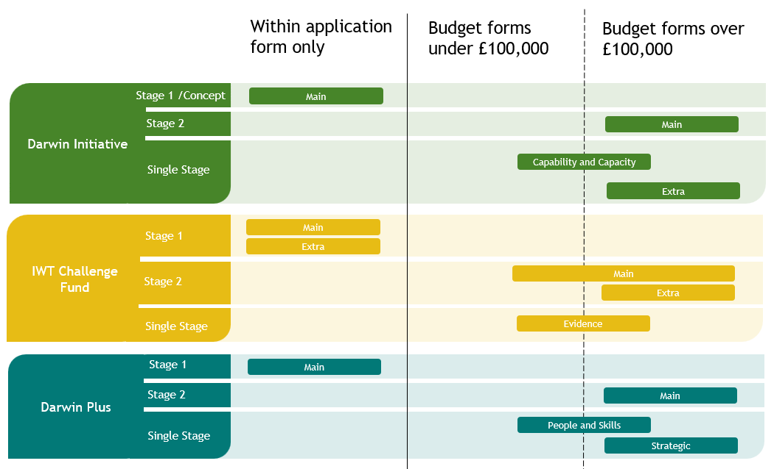
Figure 1: Which budget form should be used?

Pre-award: Financial Capability and Capacity Assurance

Financial obligations of the grant holder
As set out in the grant Terms and Conditions, grant holders must fulfil their responsibilities and obligations including:
- Ensuring that the project funds are properly used for eligible activities;
- Ensuring proper financial accountability, through adequate financial management (including, but not limited to, adequate controls, accountability structures and procedures to ensure transparency) in accordance with the financial guidance;
- Retaining all invoices, receipts and accounting records and other relevant documents relating to the project funds for a period of seven years after the expiry of the grant. Such records should be made available at the Fund Administrator’s reasonable request for audit purposes;
- Keeping the Fund Administrator regularly informed of forecast spend during the lifetime of the grant;
- Organising and ensuring the audit requirements are met on time;
- Reporting and investigating cases of Fraud in a timely manner;
- Complying with the Terms and Conditions of the grant.

Lead Organisation
Evidence of the Lead Organisation’s current financial situation through audited or independently examined accounts covering a minimum of the last three years must be provided as required by the fund you are applying for.
The review of financial capability and capacity will be based on the following questions:
- have you submitted the requested financial statements, examined as required?
- if the accounts are not in GBP and/or English, have you identified the currency and provided all key information in English?
- are there comments from the auditor/independent examiner that raise concern and, if so, have you explained how they have been addressed?
- is there sufficient evidence to show you have successfully managed grant funds in the past?
- does your profit/loss level demonstrate that the organisation is sustainable?
- have you provided evidence of sufficient reserves to allow you to continue to deliver your project if you face financial challenges?
- is your level of income in the last two years sufficient to demonstrate you could manage the level of funding you are applying for?
If there are reservations on any of these areas, you will not automatically be rejected, but additional checks may be required.
Additional requirements on how payments are handled may also be applied if reservations are raised. For example, you may be asked to apply for advance funds based on actual expenditure each quarter rather than the standard payment process (see Section 5).
As an indication, the maximum annual value of funds requested should not exceed 25% of the Lead Organisation’s average annual turnover/income for the previous 3 years.
For example, if your project request is for £250,000 (£75,000 in year 1, £125,000 in year 2 and £50,000 in year 3), you would be assessed based on the largest annual value of £125,000 and would therefore need to demonstrate a turnover of at least £500,000 per annum in at least one of the previous 3 years.
Applicants that are unable to demonstrate this will only be considered in exceptional circumstances and should be able to provide clear evidence of previous projects managing a level of funds similar to the request from BCFs.
Should an applicant not meet this level of turnover , applicants should provide a statement and, if appropriate, supporting evidence (e.g. a letter of support from a parent organisation, recent funding awards if current turnover/income is significantly higher than in the last few years, current balance sheet) to provide further evidence of financial capability and capacity.
Where non-UK based government departments and agencies are eligible to apply, they are not required to demonstrate financial capacity via audited accounts or other means, but are still expected to demonstrate technical capacity on similar sized projects and ability to meet the financial requirements set out in the Terms and Conditions.

Grant requests under £100,000
We do not require audited or independently examined accounts for the last two years, but you should be able to provide appropriate evidence and demonstrate your financial capability and capacity via a year-end financial statement or the latest management accounts as a minimum

Submitting your organisation’s accounts
Accounts and financial information must be submitted in English (unofficial translations of the financial statements and any relevant notes or comments from the auditor will be accepted) and include the following:
- the last two separate sets of full formally audited/independently examined and signed accounts with comparative figures provided for two financial years (effectively providing the last 3 years financial information);
- the most recent set of accounts should be no older than one year, unless adequate explanation can be provided. If this is the case, a copy of unaudited management accounts can be provided as well as the prior two years’ audited/independently examined financial statements.
- please be clear in which currency figures are presented.
Accounts must be uploaded to Flexi-Grant as PDFs no larger than 5MB: if this is not possible, please upload an explanation (PDF format) and email the zipped files to the relevant application mailbox.
Please do not send hard copies or links to websites as these will not be considered a valid submission.

Post-award: Claims and processes
This section explains how the claims process works if your application is successful.

Standard Payment Procedures
Please ensure that the standard payment process detailed below is compatible with how your organisation works before you apply:
- Projects make three quarterly advance claims for payments, based on forecast spend, with the fourth quarter (Q4) payment in arrears, after year end.
Variation from this standard approach may be possible if justified and agreed in advance. ‘Advanced Actuals’ allows a project to make an advance claim in Q4, but we would not expect to pay out the balance for the year. Each quarter must be accounted for before the next advance is paid.
Claim forms are available and these are updated periodically, and it is your responsibility to ensure the correct form is used every time.
You must submit a claim for each payment. Your submitted claim starts the payment process.
Claims submitted on an incorrect template, with errors or with omissions will be rejected, and delay the payment of funds. We do not require invoices from your organisation.
Before the start of each new financial year, you will receive confirmation of the award offered for that year; you must accept this award for payments to continue. Delays in receiving the signed Award or Annual Grant Acceptance Form, may result in processing and payment interruptions.
All claims are checked before being submitted for payment. The intention is to pay within 15 working days of approving a valid and accurate claim (see requirements below). You will be advised when the claim has been processed, although it may several days for the funds to arrive in your account.
Factors can introduce delays in processing claims, but you will be kept informed of any known issues.
All claims must be submitted by email, with a clear signature that matches the signature panel on the Grant Acceptance Form, or with a revised signatory panel (template available).

Claims from and payments to non-UK bank accounts
Lead Organisations with non-UK bank accounts should be aware that international payments, in particular the first payment, may take time to arrive and you should plan accordingly.
New grant recipients must fully and accurately complete ‘Part C. Payment Details’ on the Grant Acceptance Form; failure to do so may result in a delayed payment.
On the Claim Form, you are asked to provide confirmation of bank details, this needs to be completed in full for every claim submitted.
BCFs will only pay in GBP, but can instruct the bank to pay in EUR or USD to suit your account if requested; the associated exchange rate risk is for the project to manage.

How the claims process works
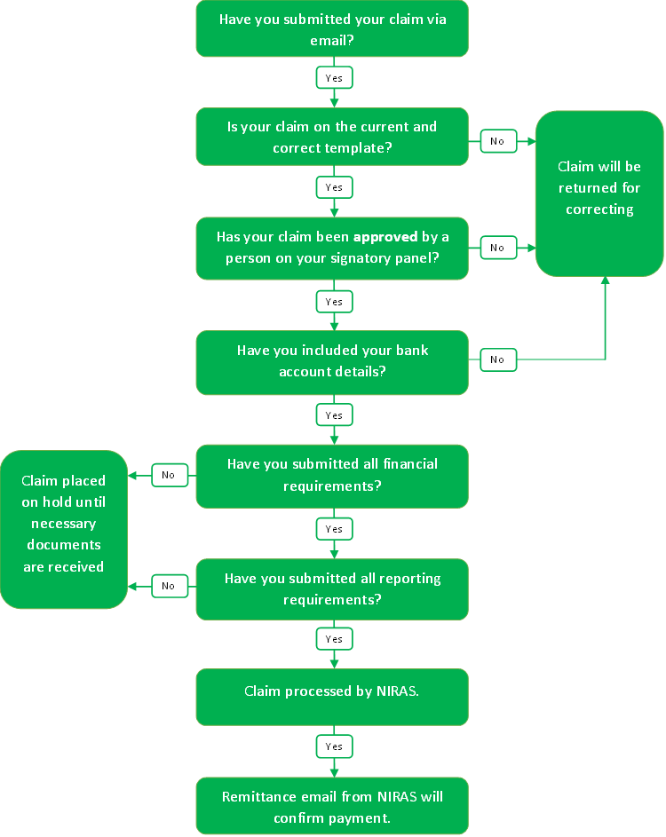

Payment Schedules
Awards are payable in quarterly instalments: the first three quarters are paid in advance, with the fourth quarter normally paid in arrears. Projects must provide accurate forecasting information so that advance claims are based on actual expected spend in that quarter.
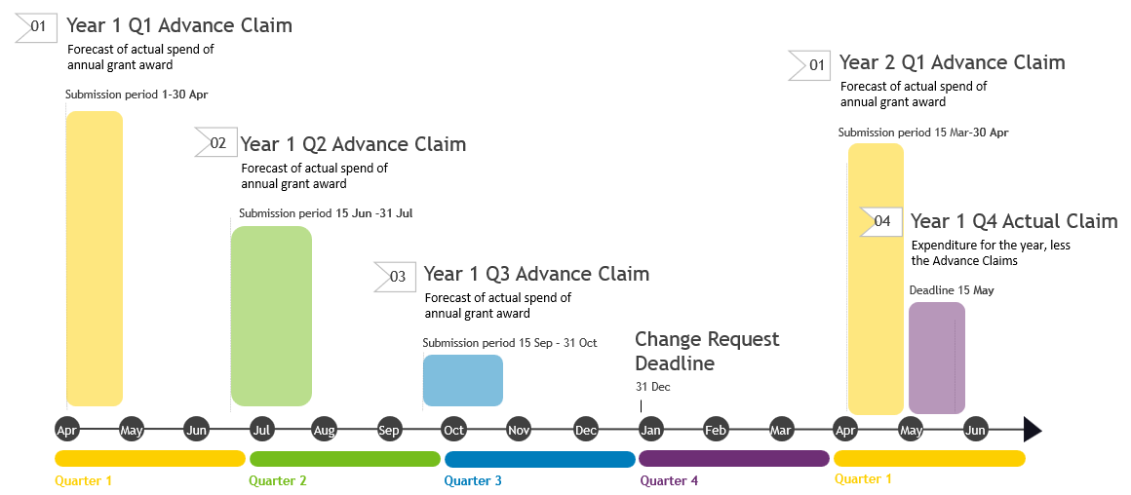
Figure 2: Payment schedule for BCFs projects

Quarterly advance claims (excluding final claim where retention figures at 5.3.3 must be considered) should be submitted as follows:
Claim | Amount | Covering the period | Submission period
FY Quarter 1 – Advance Claim | forecast of actual spend | 1st April to 30th June | 15th March – 30th April
FY Quarter 2 – Advance Claim | forecast of actual spend | 1st July to 30th September | 15th June to 31st July
FY Quarter 3 – Advance Claim | forecast of actual spend | 1st October to 31st December | 15th September to 31st October

A Q3 claim should leave a balance of a minimum of 10% of the annual award figure and should carefully consider the realistic needs of the project to avoid overclaiming.
For projects that start after 1st April, the first payment will made at the start of the project for the relevant quarter it falls in, before reverting to the above quarterly timings. For example, if your project starts on 1st May your Q1 forecast will be for 1st May to 30th June, then you fall into alignment for future quarters.
To demonstrate good financial management, it is important that projects produce accurate forecasts and make timely claims for what you need. This provides Defra assurance that the portfolio level forecast is accurate and helps to avoid difficult financial decisions that can severely impact on the BCFs’ ability to award new grants.
Defra retains the right not to pay claims submitted later than indicated in the agreed payment schedule.
Project expenditure must be accounted for on an actuals basis, so the fourth quarter claim will be based on the actual expenditure for the year less the advance claims; this is referred to as the Actual Claim.
You must submit an Actual Claim, even where no additional funds are claimed or you have overclaimed.
Claim | Amount | Covering the period | Deadline
Actual Claim | Expenditure for the year, less the Advance Claims | 1st April to 31st March | 15th May

Ongoing projects must submit their Actual claim by 15th May each year; claims submitted late may not be paid and this may result in the curtailment, suspension or termination of the project.
Poor financial management, including non-compliance with deadlines or being unresponsive to email requests, is not acceptable and may impact future funding.
The Actual Claim is paid in arrears, so projects need to ensure that they are able to accommodate this.

Overclaims
While we expect projects to manage their budgets and forecasts accurately, we recognise that plans can change. In some cases, a project may reasonably claim more than it has actually spent within a financial year. When this happens, the difference will appear as an overclaim in the Q4 Actual claim.
Any overclaimed funds will be deducted from payments in the following financial year and will reduce the amount available to claim. In other words, the overclaim does not increase the total award for the year.
Because the Q1 payment is normally released before the Q4 Actual claim is submitted, it is likely that any overclaim will be offset against the Q2 claim, as illustrated in the example below.
 | Q1 | Q2 | Q3 | Q4
Year 2 forecast | £25,000 | £32,000 | £20,000 | £16,000
Year 1 claim Q4 Actual claim – overclaim amount | 0 | £5,750 | 0 | 0
Year 2 actual payments | £25,000 | 26,250 | £20,000 | 16,000

 | Year 1 Claims | Year 2 Forecast | Year 2 Actual Payments
Q1 | £25,000 | £25,000 | £25,000
Q2 | £25,000 | £32,000 | £26,250
Q3 | £30,750 | £20,000 | £20,000
Q4 Actual | £25,000 | £16,000 | £16,000
Total Budget | £100,000 | £93,000 | £93,000
Comments | Exceeded annual budget by £5,750 |  | Annual claims reduced by £5,750

Final year of Project
An Advance Claim cannot be made for the quarter in which the project is due to complete: up to this point the standard payment schedule is followed. You should consider any implications this may have for your project.
A final Actual Claim should be prepared detailing the actual expenditure in the final year, and submitted to BCF-Finance@niras.com within 3 months of the agreed project end date.
Your final Actual Claim will only be paid once your Final Report has been received and is dependent on the Final Report Review and Audit being acceptable. This may be some time after your project ends.
Late or sub-standard reporting may result in any outstanding claims not being paid.
We do not require consolidated project accounts in either the final report or the last claim.

Retention
For all projects we retain a portion of the grant in the final year until all the reporting and financial requirements are met. If you have a very small award figure in the final year, some of the balance from the previous financial year may also be retained. This will impact when you will receive the last payment for your project and you should ensure you budget with this in mind.
- Total BCFs award over £1,000,000
Either 25% of the total award for the final year or £50,000 whichever is greater, will be withheld.
These funds will be paid on acceptance of the Final Report and Audit Statement.
- Total BCFs award between £100,000 - £1,000,000
Either 25% of the total award for the final year or £20,000, whichever is greater, will be withheld.
These funds will be paid on acceptance of the Final Report and Audit Statement.
- Total BCFs award between £50,000 and £100,000
Either 25% of the total award for the final year or £5,000, whichever is greater, will be withheld.
These funds will be paid on acceptance of the Final Report and, for grants greater than or equal to £50,000 but under £100,000, the audit statement (see section 6.6).

- Total BCFs award under £50,000
Either 25% of the total award for the final year or £3,000, whichever is greater, will be withheld.
These funds will be paid on acceptance of the Final Report.

Where issues of probity, governance, or control are discovered, Defra retains the right to recover or withhold funds.

Conditions for Payment
The payment cycle is tied to the technical and financial reporting; failure to meet the reporting or financial reporting requirements in a timely manner and to the expected standard will impact payments.
The normal required evidence for payments can be summarised as follows:
Claim | Deadline | Financial Evidence | Technical Evidence
Quarter 1  1st April – 30th June  Advance Claim | 15 March - 30th April | Year 1: Grant Acceptance Form  From Year 2: Annual Grant Acceptance Form  Advance Claim | n/a
Quarter 2  1st July – 30th September  Advance Claim | 15th June – 31st July | Year 1: n/a  From Year 2: Verified Q4 Actual Claim (from previous FY) even if no outstanding funds to claim | From Year 2: Annual Report Due by 30th April.
Quarter 3  1st October – 31st December  Advance Claim | 15th September – 31st October | Year 1: n/a  From Year 2: Annual Audit from previous Financial Year for Extra and Strategic projects | From Year 2, prior year Annual Report Accepted
Quarter 4  1st January – 31st March  Actual Claim | 15th May | Confirmation of Actual spend across the FY even if no outstanding funds to claim | Annual Report due by 30th April
Final Actual Claim,  less retention | <3 months of project end | Verified Final Actual Claim | Final Report Received
Retention | <6 months of project end | Verified Audit Statement where required | Final Report Accepted
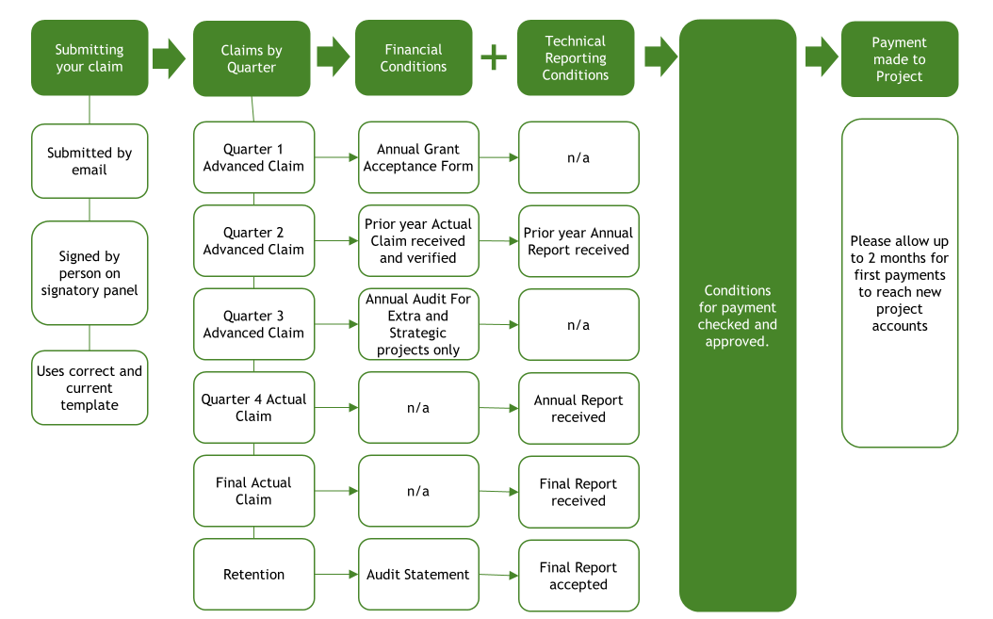
Figure 3: Conditions for payment. Conditions may vary between different grants.

Post-award: Managing your budget
This section explains how we expect you to manage your budget if your application is successful.

Good Practice
All Lead Organisations are expected to closely monitor their budget against the project plan and logframe. Some degree of flexibility within budgets is possible, but the expectation is that accurate planning and forecasting should occur upfront and that the need for revisions to the budget will be by exception only and will in most cases be anticipated well in advance by the Lead Organisation.
Defra has its own budgetary restrictions, so the quality of forecasting on all grants is very important. If you regularly spend a lot more or less than you forecast, or significantly underspend in a year, this could be considered to be due to weak project and financial management and reflect poorly on future applications.
All partners should consider the following points of best practice when designing their systems:
- Collaboration. Management of the budget is only effective when it is a collaboration between the finance section and technical delivery sections, and between Partners. Financial forecasts should be activity-based and consider the real-world actions taking place, and be aware of the local context, rather than a simple apportionment of budget across quarters.
- Forward looking. The Fund Administrator should be made aware of the need to adjust budgets as far in advance as possible. If the Lead Organisation reports budget line variances of +/-10% only during annual reports, then they are at risk of the Fund Administrator and Defra rejecting budget adjustments and denying any disbursement of funds not in the agreed budget.
- Regularly updated. It is recommended that progress, forecasts, and plans are reviewed at least monthly and accurate up to date financial forecasts provided quarterly.
- Realistic. There is an inevitable tendency to over-promise on the delivery of projects. Effective planning should attempt to control this and set a project plan closely linked to a budget which is ambitious, but achievable.

Spend relating to Financial Year
Defra allocates annual budgets based on the expected project expenditure set out in applications. The award figure must be spent in the year it relates to.
Underspends cannot be carried forward without formal approval and if a project spends more than the BCFs award available for that year, this cannot be paid from BCFs funds. Where they occur, they must be met from other sources.
This means that projects must provide accurate and realistic budgets at the outset of the project and manage their funds to a high standard.
- You can operate with some flexibility between budget lines within a financial year (<10% in any one high level budget line), but cannot change the total annual budget without agreement.
- If >10% change is needed to any budget line within a financial year, prior agreement from Defra is required (see 6.3), noting that approval is not guaranteed.
- You cannot apply any informal/internal transfers between different financial years within your own project budget without Defra’s agreement.
- If you overspend on one budget line, you must ensure you cover that from another line or meet the additional costs from matched funding or from within your own organisation.
In exceptional circumstances, for example where conflict or natural disasters have an impact on your ability to deliver, Defra may be able to offer some flexibility over budget changes. However, any such changes must be justified and be due to unforeseen circumstances beyond the control of the project, rather than poor planning, delivery or budgeting.
There are limitations to what is possible, particularly when changing budgets across the project lifetime or moving funds between financial years as this can severely impact availability of funds for other project awards. It is strongly advisable to avoid planning significant activities or expenditure in January – March in case these are delayed; moving unspent finance to the subsequent financial year at that point may not be possible.
Please contact us as soon as you become aware of an issue as we may be able to offer advice to avoid or minimise any required changes.
If you need to make a budget change and you believe you meet the criteria, you should do this via a Change Request (see 6.3) as soon as possible.

Project Change Requests
Any significant budgetary or technical project changes must receive prior approval.
This is particularly important for proposed financial changes between budget years and significant technical changes, but also includes changes to the key project staff (particularly Project Leaders) for which CVs or job descriptions and other significant project changes (e.g. to the logframe).
Project Change Requests must be submitted on the Change Request form, after you have discussed any proposed changes with your finance team and partners as relevant.
Changes can only be made to current and future years, unless the case is exceptional and clearly justified.
In BCFs terms, there is no such thing as a no-cost extension as the request to move project funds into future years impacts the funding available for new projects.
Any financial change that involves movement of budget from the current financial year must be submitted before 31st December; late requests are unlikely to be agreed unless exceptional and clearly justified.
Exceptional circumstances could include, for example conflict, natural disasters, or a new epidemic. Note that movement of unspent budget to subsequent years negatively impacts the number of new projects Defra can award.
Further details are available in the Change Request Form.

Foreign exchange
Projects will incur costs in currency other than GBP, and you should apply your organisation’s approach to exchange rates, and manage the currency exchange risk yourself.
Please ensure that at least monthly exchange rate records are maintained throughout the project.

Forecasting
A forecast is a prediction or estimate of project expenditure that is likely to be incurred over any given time period, predicting and planning for cashflow requirements as well as aiding resource planning. BCFs have now moved to paying against the amount that projects forecast they will need in the relevant quarter, rather than 25% per quarter..

Why is forecasting important?
- For Lead Organisations: For you and your partners, forecasts allow you to plan future events, based on an analysis of what has happened in the past. Forecasts should predict and reflect what funding is needed to allow you to be able to deliver everything you have planned to do.
- For the Fund Administrator: Every month, the Fund Administrator is required to submit an updated forecast of planned expenditure for all BCFs grants to Defra. The information you provide in your claims is reviewed and assessed, before being consolidated and further analysed.
- For Defra: Forecasting gives Defra an insight into the activity of the portfolio, ensures sufficient funds are available at the right time to meet the needs of projects, and allows spending to be monitored and kept in line with higher budgets and forecasting.

Financial Assurance (Audits)
The Lead Organisation must provide Defra with independent assurance that the grant has been spent in accordance with the terms of the Grant Agreement. The level of assurance is linked to the scale of the grant.
 |  |  | Statement of Grant usage certified by
Total BCF Grant | Spot Audits | Self-declaration | Independent Examiner | Auditor
Less than £50,000 | Yes | Per claim, Project End | Not required | Not required
£50,000 to £99,999 | Yes | Per claim | Project End – certification by either acceptable
£100,000 to £1,000,000 | Yes | Per claim | No | Project End
More than £1,000,000 | Yes | Per claim | Annually | Final Annual Audit

Spot Audits are conducted each year by the Fund Administrator to ensure the grant monies have been spent in accordance with the terms and conditions of the grant. See Section 6.7 below.
Self-declaration is the assurance provided on each claim including the final claim each financial year.
Statements of Grant usage are required annually from grants of £1 million or more (covering each active financial year of the project) and on completion of all grants over £50,000 to provide assurance that the grant has been spent in accordance with the terms of the Grant Agreement. Who provides the statement is set out in the table above. The statement covers the funds awarded and claimed by the BCFs. There is no requirement to check matched funding.
Where an independent examiner statement is required, this can be conducted by any independent accountant (with a recognised accounting qualification), it does not need to be conducted by a practicing certified auditor.
Where an auditor is required, they should be a practicing certified auditor.
The independent examiner/auditor should be provided with access to the full accounting information for the grant (including internal financial controls, and previous annual statements for grants over £1,000,000) to enable them to be satisfied that the figures are complete, accurate and provide appropriate explanations for all costs applied, including staff costs, foreign exchange, overheads, direct costs etc.
Auditors should sample evidence across the award, but there is no requirement to check all receipts.

The assurance process will focus on how the Lead Organisation has controlled and accounted for the funds. Information about how any project partners has spent funds should be included in the Lead Organisation’s financial records, as the Lead Organisation is accountable for these. Separate assurance processes of any project partners are not routinely required by Defra, though the auditor may wish to sample receipts as part of their work, and this should be enabled where requested.
- The independent examiner/auditor must be a full member in good standing of a professional accounting body affiliated to the International Federation of Accountants.
- Matched funding does not need to be included in the audit of the grant.
- The financial assurance at the end of the project is in reference to the entire project grant.
- The independent examiner’s/auditor’s report should clearly show the total grant funds claimed against the total amount spent, or provide a clear explanation if it differs significantly.
Lead Organisation Audit: For all projects over £1,000,000, a copy of the annual audited accounts for the Lead Organisation covering the Funding Period also needs to be submitted with audit of the grant at the end of the project, or as soon as realistically possible when available. If this is not available at the time that the Statement of Grant Usage is ready for submission, then please contact the Fund Administrator.
The final project spend should not exceed the agreed budget at the time of the award, taking into account any agreed Change Requests. Any project costs over the award figure should be met by matched funding.
The project’s final claim should be submitted within three months of project end. This allows the audit to be undertaken in parallel with the review of the Technical Final Report so the final claim can be reviewed and paid as quickly as possible.
This final Statement of Grant Usage must be provided within 6 months of project end and should cover all funds provided by Defra, including the final claim and the audit cost.
The final Statement of Usage should include at least the following wording or its equivalent and must include the total BCFs figure claimed:
Name of Organisation:
Project Title:
Project Ref No:
I have examined the accounts, records and claims relating to this grant for the period [start date] to [end date]. I confirm that the total grant monies of [£total claimed] were fully and solely expended for the purposes set out in the original Grantee Application (or as subsequently agreed with Defra) and in accordance with the terms and conditions for the grant.

Spot Audits on expenditure and procedures
Every year, a proportion of projects will be identified for a Spot Audit to ensure the grant has been spent in accordance with the agreement with Defra. You are required to respond to any such request as quickly as you are able to, and meet deadlines provided.
Defra uses a random sampling process, so your project may be requested to participate more than once.
To allow us to so review your internal financial controls and procedures, if you are selected you will be asked to provide:
- electronic information about all the transactions accounted for in a specific period and the Fund Administrator will identify a selection of transactions;
- copies of original receipts, invoices and timesheets supporting these transactions.
- additional information such as an asset register and supporting evidence, an Anti-Bribery and Corruption policy, Foreign Exchange Policy, Risk Register.
- Items ineligible for funding
Under Government policy, there are a variety of items that are not normally acceptable for government funding and these are set out in the Terms and Conditions of Award (see clauses 5.3 and 5.4 of the Terms and Conditions).
For BCFs projects, there are additional items that would not be considered eligible. These are summarised below and split into two lists. The first list covers items that are not and cannot be eligible. The second covers items not generally acceptable, but which could be considered acceptable in particular circumstances, as summarised below.
Not eligible
- gifts (except for gifts below £10 in value, typically educational or promotional materials which disseminate awareness of the project and further its aims),
- bribes, facilitation payments and any other inducements to obtain favourable treatment,
- any costs which do not clearly advance the aims of the project, or expenses that cannot be reasonably linked to activities that support those aims,
- any costs which are not essential to the project activities as outlined in the approved project proposal by Defra or agreed upon through the formal Change Request process,
- any costs which are the personal responsibility of the individuals who received benefits from them, such as travel expenses to and from home, clothing that is not a uniform or personal protective equipment, consumer electronics that provide significant personal benefit, and travel and hotel expenses for partners or family,
- any costs which a reasonable person would consider excessive, extravagant or wasteful.
Not normally acceptable
- We understand that workshops and fieldwork are essential for many projects, and it is reasonable to provide some hospitality for those who attend, especially if they are traveling long distances. However, excessive hospitality that does not significantly contribute to the project's outcomes is not allowed,
- tips and gratuities are generally not allowed, but small amounts under £5 may be accepted,
- extra-contractual payments and bonuses (if the Lead Organisation wants to provide a bonus, with project funds, for outstanding performance this should be requested via a Change Request),
- alcohol.
- High Level Budget Characteristics

Value for Money
Projects must demonstrate good Value for Money in terms of impact and cost-effectiveness of each pound spent.
- Value for money means aiming for the best feasible project, not just a good project. This means drawing on evidence to carefully appraise possible objectives and delivery options, considering how to use competition and thinking creatively about how to get the best impact.
- That doesn’t mean that we only do the cheapest things. We need to understand what drives costs and make sure that we are getting the desired quality at the lowest price.
- Nor do we just do the easiest things to measure. We need to explain what we value, be innovative in how we assess and monitor value for money and what results we are trying to achieve with UK taxpayers’ money.
- Value for money is not something that applies only to project design. It should drive decision making throughout the project cycle and in relation to running costs and evaluations.
Partners must demonstrate that they are pursuing continuous improvement and applying stringent financial management and governance to reduce waste and improve efficiency.
We expect Projects to demonstrate openness, honesty and realism about capacity and capability, accepting accountability and responsibility for performance along the project chain, in every-day and exceptional circumstances.
To maximize the impact of UK aid, there is a need to be very clear about the expected outcomes and costs, and to have confidence in the evidence and underlying assumptions.
Additionally, when we look at the effectiveness of an intervention, we need to consider issues of equity: making sure our results are targeted at the poorest and include sufficient targeting of women and girls.
You should frame your approach to Value for Money in a wider context of how the overall benefits will outweigh the costs. Consider the change you want to create and the benefits that will result from the investment.

Economy:
Are you buying inputs at the right quality and price? Inputs are things such as staff, consultants, raw materials and capital that are used to produce outputs.
- What are the project’s major costs and what drives the pricing of those costs?
- What actions can you take to control those costs?
- Staff costs are a significant project expense. How do project staff costs compare to others working on similar issues or in the same country?
- If staff costs are higher than the benchmark, then why must they be at that level?
- What overhead cost recovery are you including in the project budget? Is this comparable with other projects? If not, then what reasons are there for the difference?
- Which cost categories will be subject to competitive procurement, and how robust is that process?

Efficiency:
How well do you convert inputs into outputs? Outputs are results delivered by you.
- What economies of scale have you been able to identify in your project?
- What is the project cost per beneficiary and how does this cost compare to industry benchmarks?
- What is the matched funding contribution to the project and what efforts have you made to maximise that?
- Would increasing the scale of the project lower the cost per beneficiary, and if so, why are you not aiming to deliver a larger project?
- What are the most expensive activities and how will demonstrate that you are conducting these in an efficient manner?
- What controls will you put in place to ensure that you are delivering the goods or services in the most efficient manner?
- Can you demonstrate experience in meeting project deadlines and milestones?

Effectiveness:
How well are the outputs achieving the desired outcome? Noting that you do not exercise direct or total control over outcomes.
- If your project will be delivered in a difficult environment, do you have evidence of your capability to deliver in such environments?
Your theory of change should demonstrate:
- Outputs that are “necessary and sufficient” to deliver purpose,
- Realistic and credible assumptions analysing key externalities in sufficient depth,
- A causal chain that is strong and evidence of its strength is verified,
- Indicators that are clearly relevant and robust.
The project may have leverage and replication potential:
- Leverage of other activities/investments and wider effects are described with evidence that shows significant potential for expansion or replication,
- Very high potential for additional benefits identified. For example, scale up, multiplier or replication.

Additionality
An important aspect to value for money is assessing the additionality of the project’s activities.
- Can you demonstrate clearly that you cannot carry out the project without help from the BCFs?
- Can you show that the planned activities will not displace initiatives that already serve your intended beneficiaries?
- Can you show that other parts of your organisation will not struggle if the persons you choose to implement the project are taken from their current work or commitments?
- If you assist your beneficiaries as planned, are there other positive impacts that will accrue to them that you might reasonably attribute to your project, as they wouldn’t have otherwise happened?
- Will there be useful lessons arising from this work? If so, how will you provide those lessons?

Equity
Equity is a core component of Value for Money and should be considered alongside effectiveness. Projects must demonstrate how benefits are distributed, with a clear focus on poverty reduction and on women, girls and other marginalised and vulnerable groups, in line with Defra ODA requirements.
- How focused is your project on the most vulnerable and marginalised populations, in particular girls and women and what evidence supports this approach?
- If there are beneficiaries beyond vulnerable and marginalised populations, then you will need to present and justify the reasons why others are also targeted.
- How does the project contribute to poverty reduction, and which groups are expected to benefit most?
- How do poverty reduction and Gender Equality, Disability and Social Inclusion (GEDSI) objectives interact within the project design?
- Are there anticipated poverty reduction impacts that do not directly support GEDSI objectives, and how are these risks identified and managed?
- How will the distribution of benefits across different groups be monitored and assessed over the project lifecycle?
Projects should demonstrate a clear understanding of who benefits, who may be left behind, and how the design and delivery of the project maximises equitable outcomes.

Cost-effectiveness
Cost-effectiveness considers the overall scale and quality of benefits achieved relative to total costs, bringing together analysis of economy, efficiency, effectiveness and additionality to assess overall Value for Money.
- How do the expected benefits of the project compare with the total costs over its lifetime?
- How does the project demonstrate that it will deliver the greatest feasible impact for the level of investment proposed?
- How do the analyses of economy, efficiency, effectiveness and additionality combine to support a strong overall Value for Money case?
- What trade-offs have been considered (for example, between cost, quality, scale and targeting), and why is the chosen approach the most cost-effective option?
Projects should clearly articulate how the overall benefits generated by the intervention are expected to outweigh the costs, and why this represents the best available use of UK taxpayers’ money.

Further reading on value for money
- https://icai.independent.gov.uk/report/value-for-money/
- The 5Es framework (Economy, Efficiency, Effectiveness, Cost-effectiveness, and Equity) in an international development context: https://www.gov.uk/government/publications/dfids-approach-to-value-for-money-vfm
- Applying the 5Es approach to assess VfM: 8-etf-evaluation-academy-20-value-for-money-slides.pdf

Matched Funding
Matched funding is not obligatory, but is highly desirable and will strengthen applications, it should be clearly identified in the budget which aspects will be funded by BCFs and which will be co-financed.
Matched Funding can include finance leveraged before or after the start date by the project from public and private sources, and in-kind contributions that can be quantified in financial terms.
Finance should be classified as based on the type of organisation providing it, with:
- Public finance being defined as finance from government agencies including central departments, sub-national public agencies, multilateral agencies (e.g. GEF, UNEP), donor agencies.
- Private finance including commercial operations but also philanthropy and private foundations/funds.
- In-kind contributions are resources (other than money) such as staff, facilities and equipment that are not paid for by the project, but can be quantified or valued in financial terms.
Where no matched funding is identified, applicants must clearly justify why it is not available or necessary for their project.
Sources of matched funding must be clearly identified. Defra reserve the right to request further information on the source of funding, including names of private donors.

Budget spread
You should consider the spread or profile of funds throughout your project lifespan.
It is preferable that funds are spread relatively evenly over the project lifetime, but variation from this even spread can be considered if justified. Within each financial year it is preferable for projects to avoid putting activities in Quarter 4 (January to March) where possible.

Balance of funding between partners
Applicants should ensure that there is a justified balance of funding, activities and responsibilities between partners.
Partners have a formal governance role in the project, and a formal relationship with the project that may involve staff costs and/or budget management responsibilities. We expect a significant portion of funding to be directly benefiting in-country project partners, rather than meeting the costs for international partners and their team.
Applicants are strongly advised to agree clear arrangements and understanding with all partners (including a Memorandum of Understanding as appropriate) on budgets and how funding will be allocated, routed, spent and accounted for.
At a local partner’s request, it is acceptable for the Lead Organisation to include funds within ‘their’ part of the budget to cover local partner costs. This might be to help local partners manage their finances where they have specifically asked for assistance, and you should clearly detail in the application including how the arrangement will strengthen the capability of the local partner.

Monitoring, Evaluation and Learning
Monitoring, Evaluation and Learning (MEL) costs should be included in the budget, allocated to the appropriate budget line (e.g. Staff Costs, T&S etc.). As a guide, we would normally expect to see MEL costs of between 5 and 10% of your total budget cost.

Contingency
Your budget must not include a ‘Contingency’, it must be adequate and appropriate for the project.

‘Sitting’ payments
Defra will not pay ‘sitting’ costs to supplement salaries for individuals to attend workshops.
However, Defra will pay per diem costs and other reasonable costs for partners to participate in the project, to cover meals, travel and accommodation as necessary.
You can also include salary costs as appropriate, but you should not include any costs to provide additional, direct payments for attendance at meetings which are supplementary to salaries already being paid.

N.B. Darwin Plus Local has separate finance guidance.

