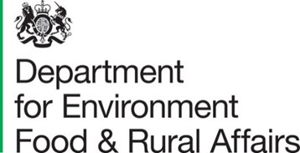

Safeguarding incident reporting form
This form is for reporting any Sexual Exploitation and Harassment, (SEAH) incidents related to Defra Official Development Assistance funded programmes. Please complete the form with as much information as possible.
For safeguarding concerns or incidents, please send the completed form to oda.safeguarding@defra.gov.uk

Details about the Defra funded ODA project
Required information | Details
Project name
Actual or estimated start date of the project
Actual or estimated end date of the project

About you
Required information | Details
Name
Organisation
Preferred contact details (email, phone number)

Details of concern or incident
Information | Details
Nature of concern or incident
(e.g. safeguarding concern)
Country where concern or incident occurred
Name of organisation that concern or incident relates to
List of all downstream partners relevant to the concern or incident
Summary of the concern or incident (outlining the key issues and any allegations)
Action taken so far
(for example, an investigation is underway, staff dismissed, reports to police)
Details of any external bodies that this allegation has been reported to (for example, Local Police, National Crime Agency, and Charity Commission) together with any crime reference numbers and reporting dates
Is there any immediate risk / threat to the individual who made the allegations? If yes, what steps have been taken to ensure their safety while the investigation is underway?
Is there a risk of continued harm to any other individuals?
What is the impact of the concern or incident on the implementation of the Defra funded activity?

Further information
Information | Details
How was this concern or allegation detected?
(for example, internal or external audit, whistle-blower, reconciliation, staff)
Please confirm whether the alleged victim/complainant is a beneficiary, research participant, contracted organisation staff member, downstream partner staff member etc.
Any other relevant details

For Defra internal use only
To be completed by SRO and shared with the ODA safeguarding lead via the oda.safeguarding@defra.gov.uk mailbox
Information | Details
Name of the Lead(s) and Contracting or Institution in relation to the Defra agreement
Has funding been suspended to the organisation?
If funding has not been suspended, please provide the date (DD/MM/YY) and amount (in GBP) of the next payment
If applicable, please provide Defra's percentage share of the funding
List all other downstream partners relevant to the allegation
Comments from relevant delivery partner and any additional information

